Multiple-choice section – choose the correct answer

Question 1 [9.5]

Which one of the following statements is false?

A Similar shapes have the same shape.

B To prove similarity, the same tests as congruency can be used.

C Two shapes are similar if all corresponding angles and side lengths are equal.

D You can calculate the ratio of the side lengths to prove similarity.

Question 2 [9.1]

For triangles ABC and XYZ,  and .  
Which test for similarity can be used?

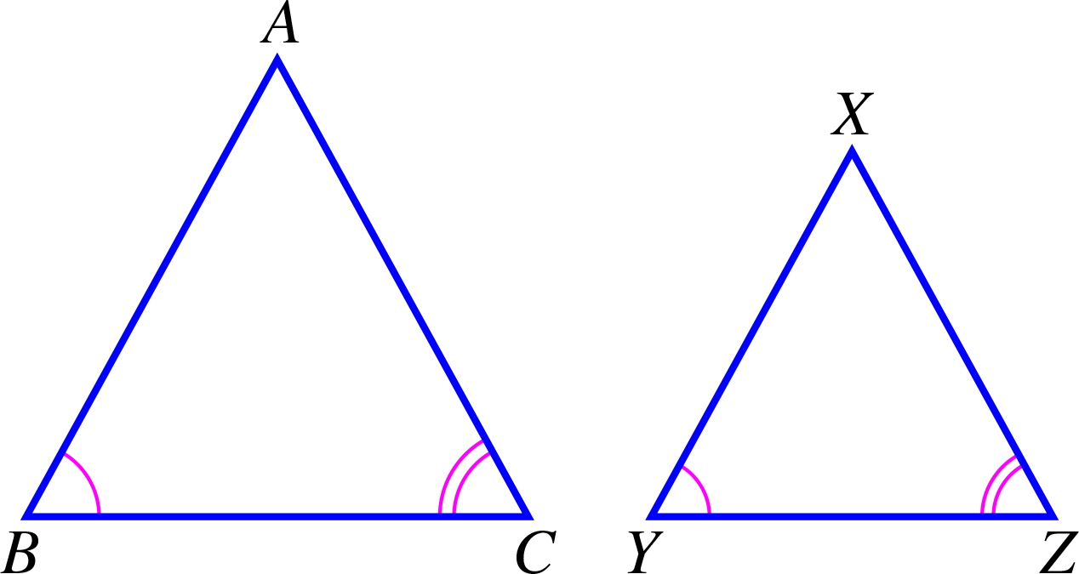

A SSS B AAA C RHS D ASA

Question 3 [9.1]

The value of x in the pair of similar triangles is:

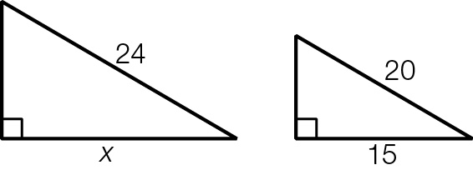

A 18 B 19 C 20 D 21

Question 4 [9.2]

If is congruent to which statement is false?

A All corresponding sides are equal.

B = 90°

C All corresponding angles are equal.

D All of the properties for similarity apply.

Question 5 [9.3]

with can be used as part of a test for congruency because:

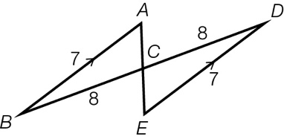

A they are alternate angles B = 180°

C they are co-interior angles D they are both acute angles.

Question 6 [9.4]

For similar right-angled isosceles triangles .  
Which statement is true?

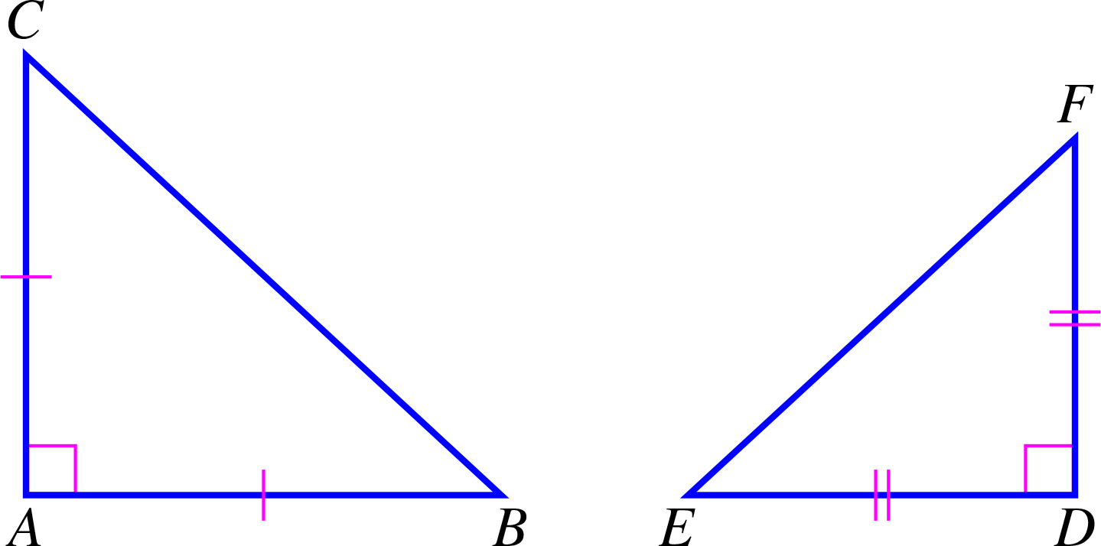

A  B 

C  D EF is parallel to BC.

Question 7 [9.2]

Which statement is true?

A If two triangles have two corresponding side lengths and a corresponding angle equal, they are congruent using the SAS test.

B If two triangles have the same area, they are similar shapes.

C If two pairs of corresponding sides of triangles have the same length, they are congruent.

D All equilateral triangles are similar shapes.

Question 8 [9.6] [10A]

What is the value of ?

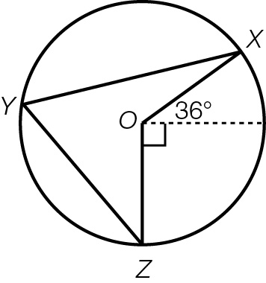

A 72° B 18° C 36° D 63°

Multiple-choice total marks: ____ / 8

Short answer section

Question 9 2 marks [9.2]

Use words from the list below to complete the following sentences.

bisect included angle definition perpendicular bisector

congruent similar theorem perpendicular

(a) To ______________ a line is to divide its length into two equal lengths.

(b) If two shapes are identical in shape but different in size, they are said to be _______________.

Question 10 2 marks [9.1]

Explain what are congruent shapes, using an example to help you.

Question 11 4 marks [9.4]

Triangles ABC and XYZ are similar.

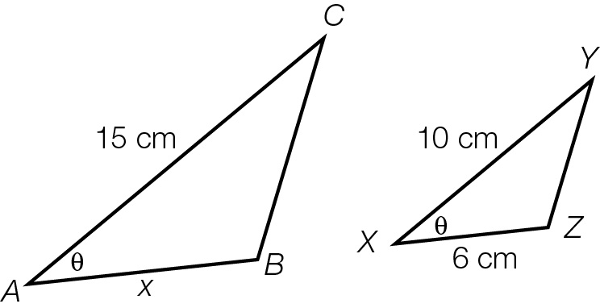

(a) State in fraction form, the side ratio.

(b) Find the value of x.

Question 12 2 marks [9.2]

Explain why two equilateral triangles that have a side of equal length are congruent triangles.

Question 13 5 marks [9.2]

A rectangular garden of dimensions 2.4 m wide × 7 m has been expanded proportionally so that the width is now 3.6 m.

(a) Draw a sketch of the two gardens labelling the new length x m.

(b) If the old garden shape and the new shape are similar figures, what is the length of the new garden?

(c) The garden will be enlarged again, with the new length being 17.5 m.  
What will be the width of the garden now?

Question 14 3 marks [9.2]

(a) Show that  and  are congruent.

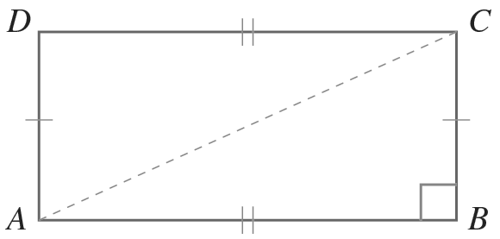

(b) Can other congruency tests be used for these triangles? If so, which other tests?

Question 15 2 marks [9.1]

The small triangles in the diagram are all equilateral.

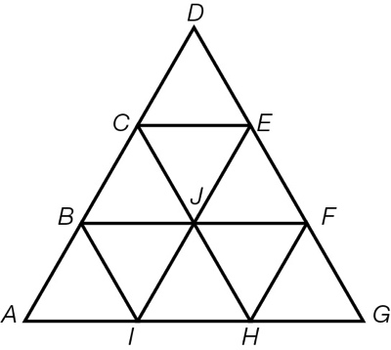

Name two different-sized triangles that are similar to .

Question 16 3 marks [9.2]

The parallelogram ACEG has midpoints at B, D, F and H.

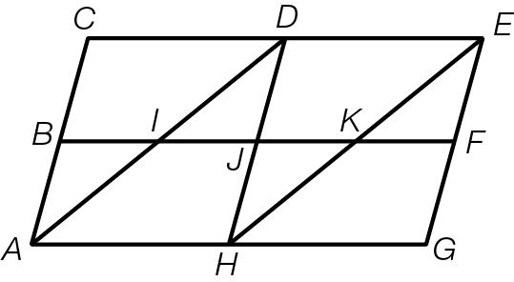

(a) List three triangles that are similar to .

(b) Which shapes are congruent to ABJH?

(c) How many pairs of vertically opposite angles are there?

Question 17 3 marks [9.3]

Prove that .

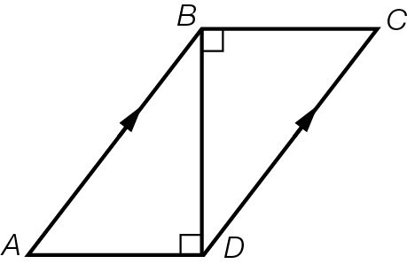

Question 18 4 marks [9.2]

A ladder rests on a 1.5 m wall with one end against a tree at a height of 5 m above the ground and the other end on the ground. If the wall is 0.5 m from the bottom of the ladder, find the:

(a) horizontal distance, in metres correct to 2 decimal places, of the base of the ladder from the bottom of the tree

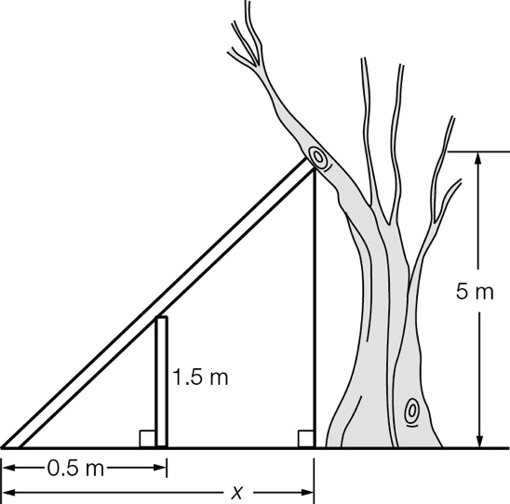

(b) horizontal distance, in metres correct to 2 decimal places, of the wall from the bottom of the tree.

Short answer total:_____ /30

Extended answer section

Question 19 3 marks [9.3]

Show that when .

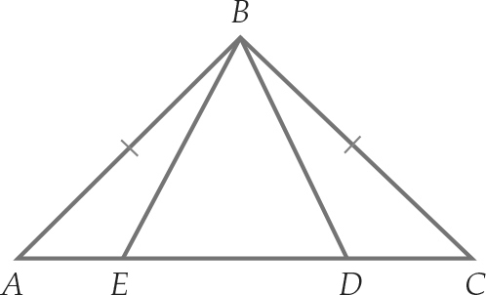

Question 20 6 marks [9.4]

(a) Why are the two triangles in the diagram similar?

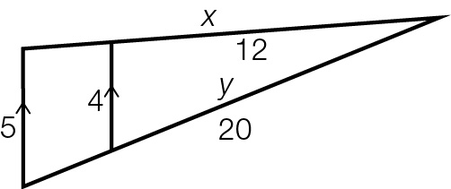

(b) Find the length of x, a side on the large triangle.

(c) Find the length of y, a side of the small triangle.

Question 21 6 marks [9.4]

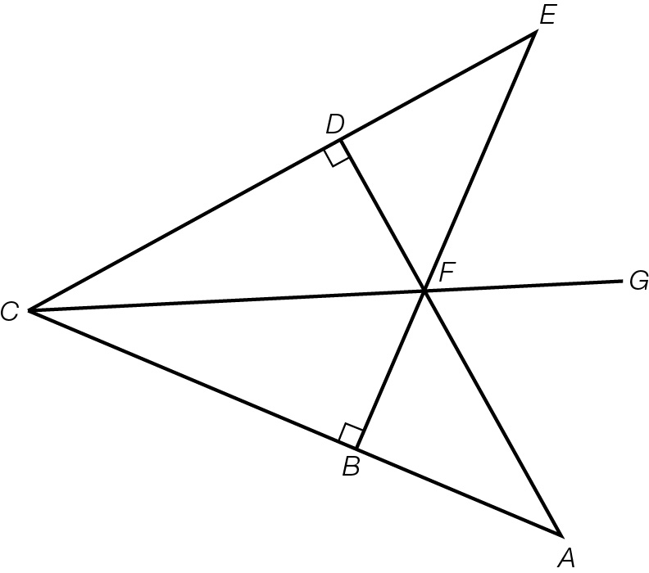

In the diagram, AC = EC and AF = EF.

(a) Prove that 

(b) Prove that CG bisects 

(c) Prove that 

Question 22 4 marks [9.6] [10A]

Point O is the centre of the circle. Show that:

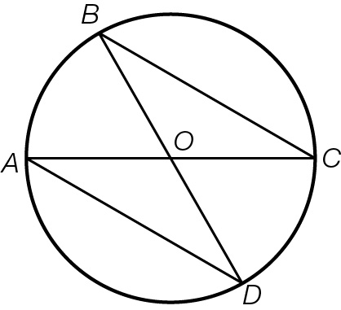

(a) 

(b) 

Extended answer total:_____ /19

TOTAL test results: ____ / 57